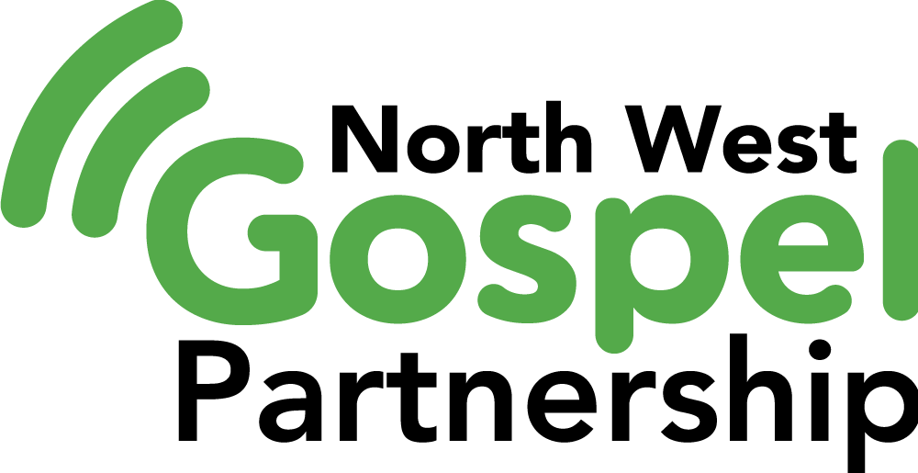

North West Ministry Training Course 1st Year
Application Form

Course Information: For specific information about the ministry training courses please visit www.northwestpartnership.com/trainingcourse

Which course you are applying for:

Personal Details

Title Name

Address

Phone number(s)

Email

Church

Date of Birth

Occupation

Data Protection
Please tick if you do NOT wish for us to share your contact details with other students □

Please tick if you do NOT wish for your photograph to be used on any North West Gospe; Partnership publicity □

Commitment from Applicant

Please read the following information which explains the commitment you make when signing up to this course:

1) Preaching Groups - Each week students are given the opportunity to teach the bible to one other in a small group setting. You will be allocated a passage from which you have to prepare a short talk (1-2 talks per term). Giving talks is the easiest and most effective way of showing that you have understood the basic tools of interpreting and applying the bible.

Therefore the commitment is:

- You will give all the talks you are allocated during the year OR in exceptional circumstances submit a transcript of what you would have presented for feedback from your small group leader.

2) Attendance – it is important that you attend regularly. If you do have to miss occasional weeks there is the opportunity to catch up online.

- You will attend at least 24 out of 30 weeks of the course (80%)

3) Fees - The viability of the courses depends on fees being paid on time. If you pull out of the course, the fees for that term must be paid in full.

Signed by the applicant …………………………………………………………

Contact Preferences - I would like
□ to receive emails in relation to partnership news and events, please indicate which category emails you would like to receive (Tick as many as apply to you)
□ Church Leadership
□ Youth Work
□ General information
□ to receive a postal copy of the bi-annual partnership magazine (online copy available)

If at any stage you which to change or withdraw consent please contact sara@northwestpartnership.com

Further information
We would be grateful if you could answer the following questions in the space provided. If you feel you need to expand an answer further, please feel free to continue over the page or attach a separate piece of paper.

1. Please describe how you became a Christian:

2. What do you consider to have been the most important thing in helping you grow as a Christian?

3. What do you consider to be your main strengths?

4. What do you consider to be your main weaknesses?

5. Why would you like to do this course?

Payment of the Course

Who will be responsible for paying your fees? – e.g. yourself, your local church, a trust? If someone else is paying please provide their name and email address.

Bursary

We have a bursary fund available. If you would like to apply for a bursary please provide a supporting statement from your sending church.

References

As the applicant, it is your responsibility to obtain a reference from your church Minister to support your application

Supporting comments/reference from Minister

Signature of current Minister in support of this application

………………………………………….

What next?

Please email applications to sara@northwestpartnership.com and pay the £50 deposit online where possible. Paper applications and cheques made payable to North West Partnership) should be send to North West Gospel Partnership, c/o 43 Sharoe Mount Avenue, Preston PR2 9HQ

Account Name: The North West Partnership
Trust Sort Code: 60-12-30
Account Number: 31513824

Receipt of your application form will be confirmed and further course information will be sent to you in mid-September.

